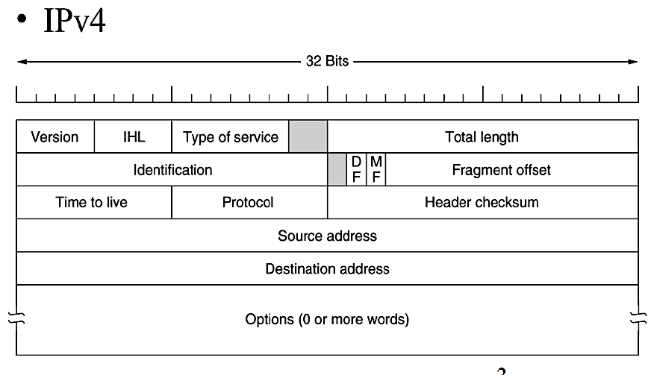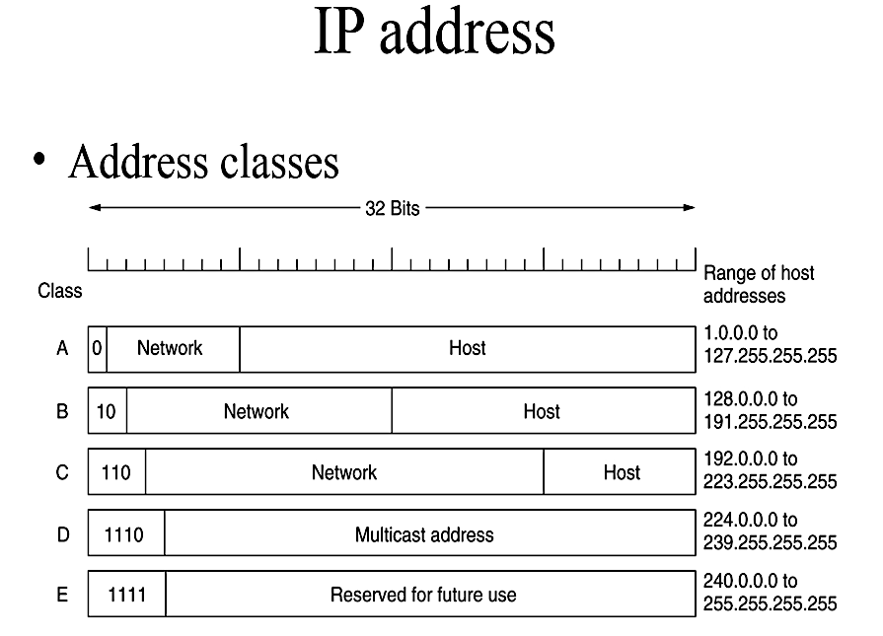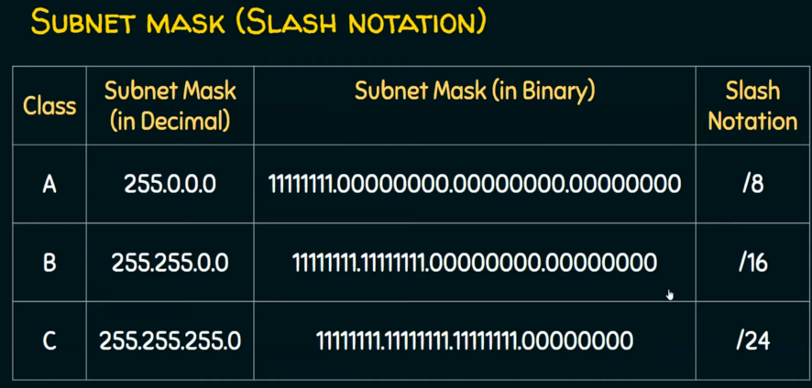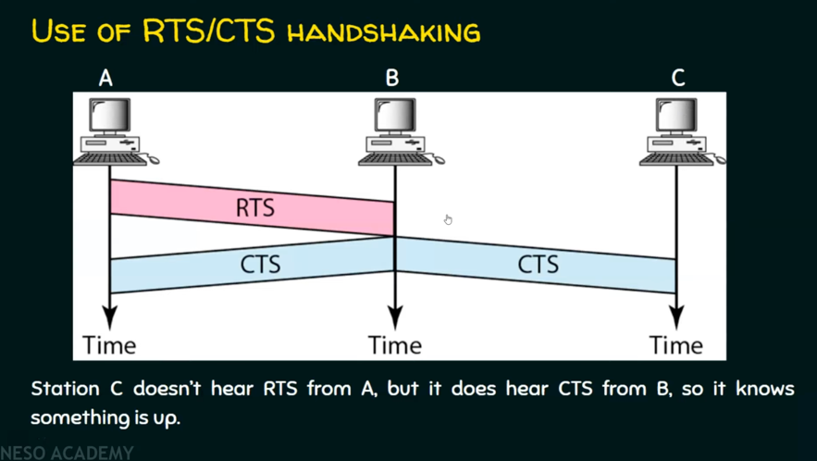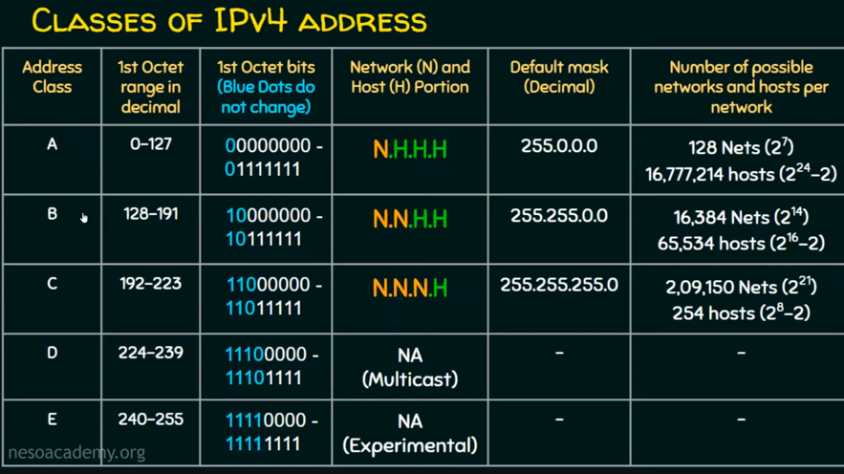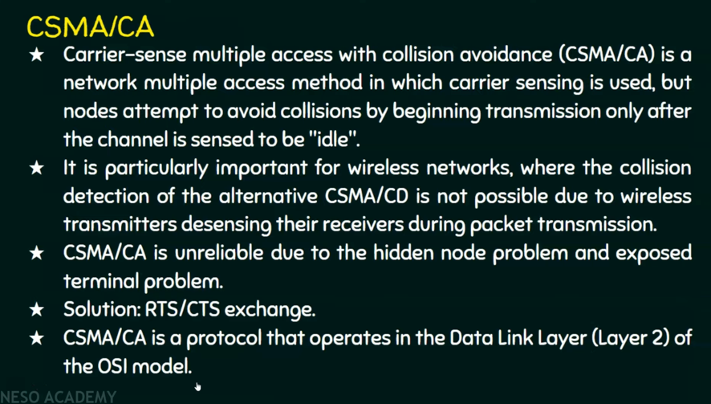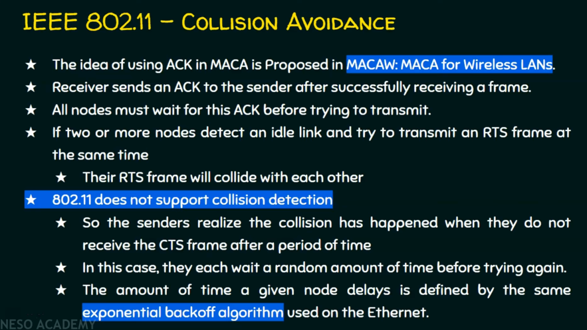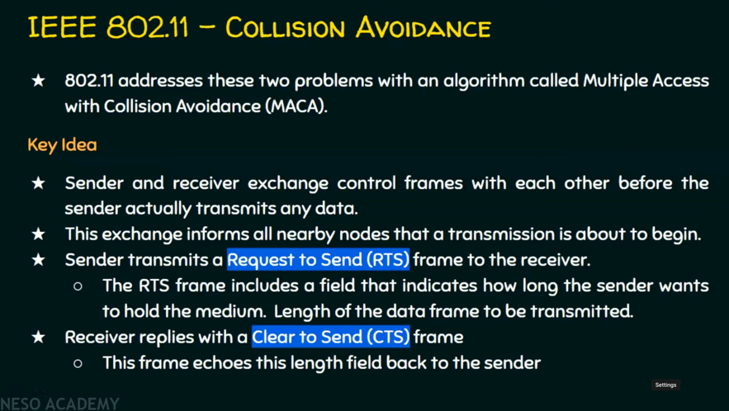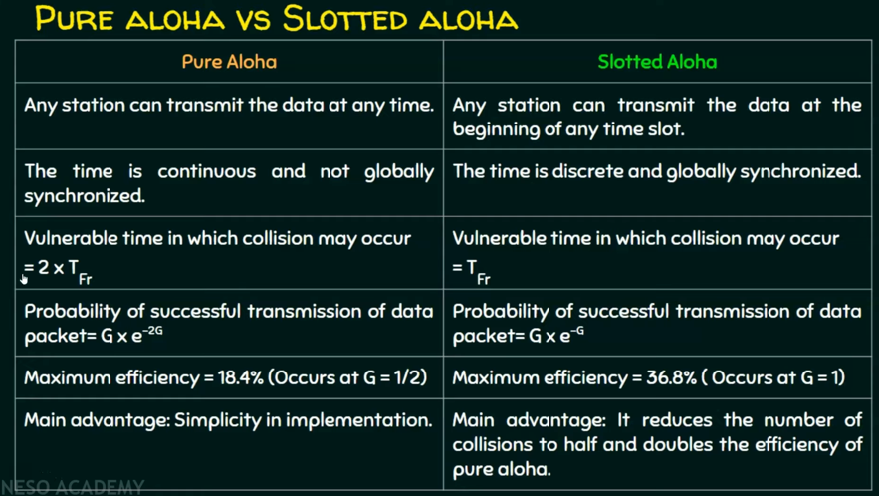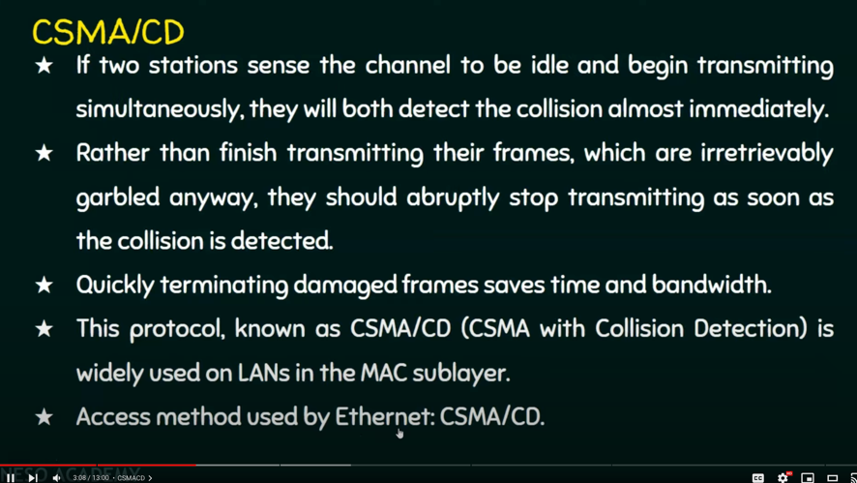

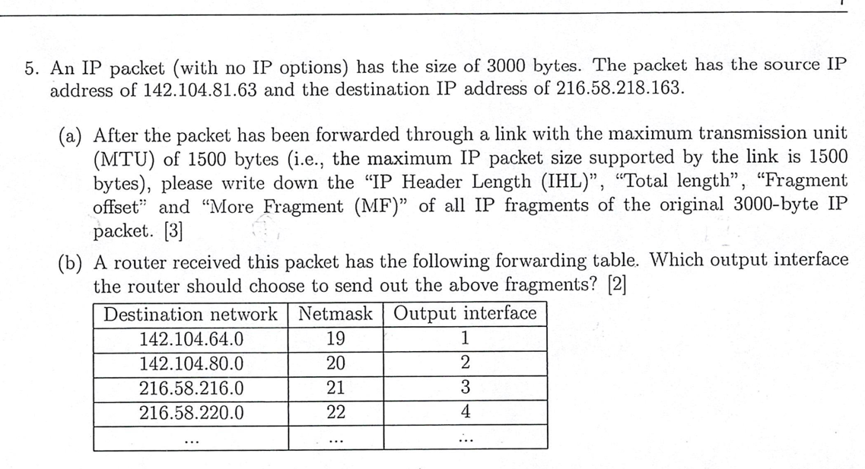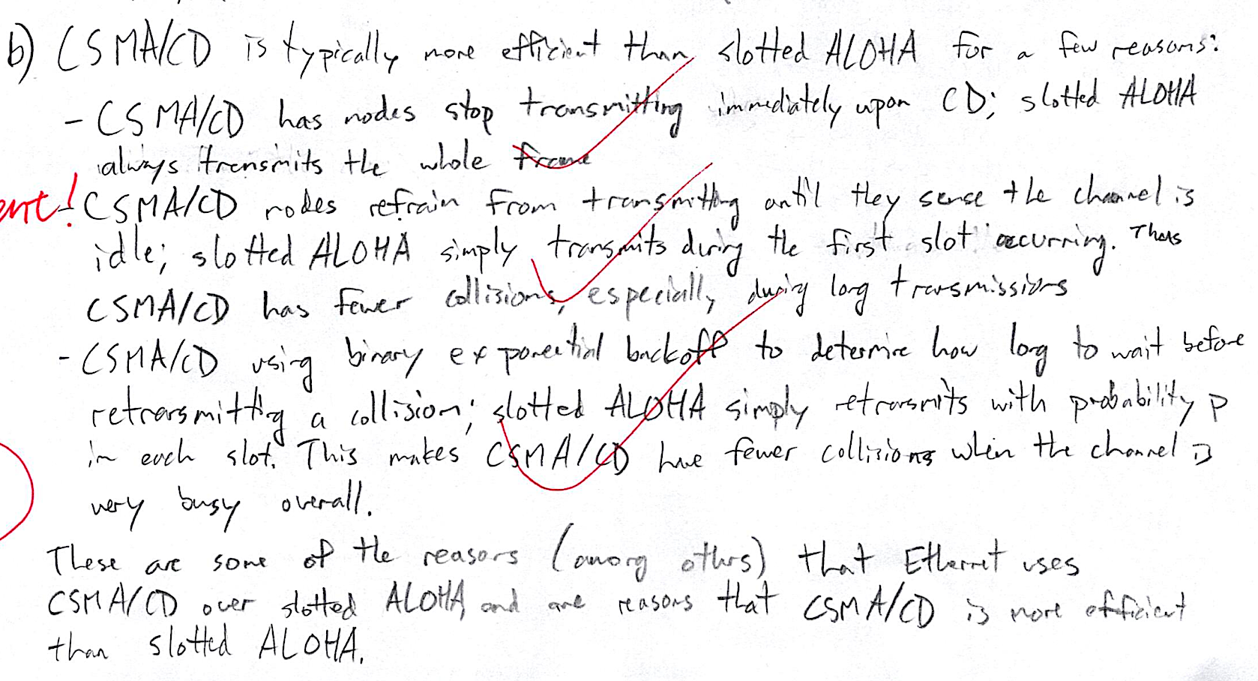

**In a communication network with a shared medium assume all packets have the same size of 1000 bytes and the transmission rate is 8 MBPS. The propagation time between nodes within the network is 100 NS. Use an example to show how Collision Detection (CD) improves the efficiency in local area networks.**

Let's consider a simplified example to demonstrate how Collision Detection (CD) improves the efficiency in local area networks (LANs).

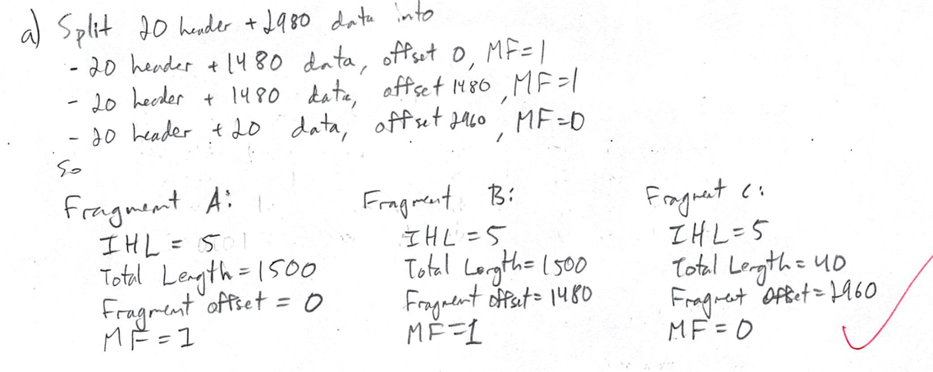Suppose we have a LAN with a shared medium where multiple nodes are connected. Each node wants to transmit packets across the network. For this example, let's assume there are two nodes: Node A and Node B.

**Without Collision Detection (CD):**

* Node A and Node B both want to transmit packets at the same time.
* They start transmitting simultaneously since there's no mechanism to detect collisions.
* As a result, their packets collide in the shared medium.
* 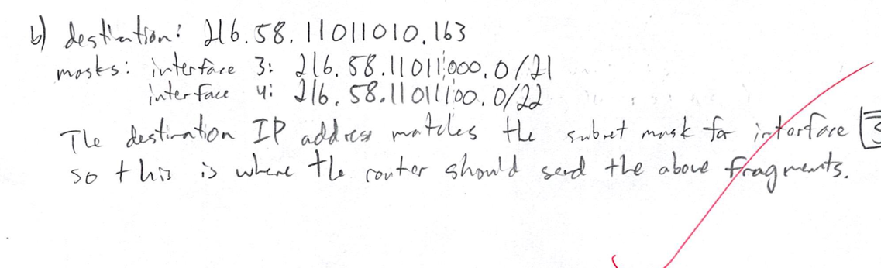Both nodes detect the collision after a certain time (based on the propagation delay) and initiate the retransmission process.
* This leads to wastage of bandwidth and time.

**With Collision Detection (CD):**

* Node A and Node B both want to transmit packets at the same time.
* They start transmitting simultaneously, assuming the medium is free.
* However, due to the Collision Detection mechanism:
* Node A and Node B can detect the collision almost immediately after it occurs.
* They stop transmitting as soon as they detect the collision.
* Each node waits for a random backoff time before attempting to retransmit.
* By stopping transmission upon collision detection, the wasted bandwidth and time are minimized.
* Eventually, Node A and Node B reattempt transmission at different times, reducing the likelihood of collision.

In summary, Collision Detection improves efficiency in local area networks by minimizing the impact of collisions and reducing the wastage of bandwidth and time. It allows nodes to detect collisions promptly and adjust their transmission behavior accordingly, leading to better network performance and throughput.

